**44. ALV_GRID_MACROS Output**

Run the report in se38.Below is the Selection screen .Give a suitable CARRID and Execute.

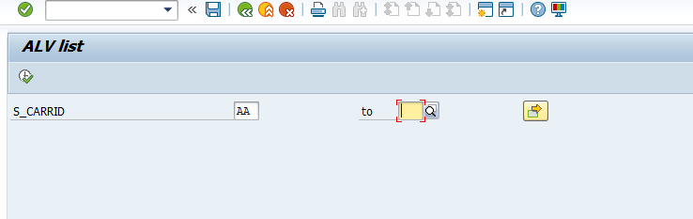

The expected output is as follows . Click on the icon created

